Conference Sponsorship Opportunities

Looking to promote your products and services at this year’s Annual Conference and 1st Locate Rodeo? Consider becoming a sponsor at the 2-day event. Sponsorship opportunities offer recognition at the Conference and highlights your support for our Association and our Industry.

Why Sponsor the Annual Conference and National Locate Rodeo?
Sponsorship is one of the best ways to brand your organization as a leader and to highlight your commitment to advancing the locating and digging industry. As a sponsor, you will be able to:
- Connect with industry decision makers. With over 200 attendees, the annual conference is the sector’s place to be heard and seen. The Association represents organizations from the Pipeline, Petroleum, Utilities, Locating, Surveying and Ground Disturbance sectors.
- Showcase your organization’s expertise at the National Locate Rodeo. The Locate Rodeo provides high-quality opportunities for attendees to have fun, compete, learn, connect, and share with their peers.
- Demonstrate your leadership. As we focus on the essential role that locators play in damage prevention of underground buried facilities, share with your colleagues the topics and work you care deeply about.
- Commitment to Damage Prevention. Damage Prevention is a shared responsibly. Showcase your commitment by supporting the Association and the Conference Educational Workshops and Presentations.

Spaces available | Cost (each) | General Description
2 | $2500.00 | Conference Lunch – Day 1
1 | $2500.00 | Guest Speaker
1 Available – 1 SOLD | $1500.00 | Networking Event – Food/Bar Service
1 | $1000.00 | Early Bird Registration Prize* (Prize Donation valued at $1000.00)
1 | $1000.00 | Conference Breakfast
SOLDOUT | $1000.00 | Locate Rodeo BBQ
SOLDOUT | $700.00 | Live Music – Stiletto Band
1 | $500.00 | Rodeo Awards – Plaques/Trophies
1 | $500.00 | Audio/Visual
1 | $500.00 | Shuttle Bus
SOLDOUT | $500.00 | Lanyards (logo)
3 Available - 1 SOLD | $250.00 | Conference Program
We hope you’ll join us as a sponsor. Together, we’ll make this the best conference yet!

*Early Bird Registration Prize will be promoted continuously prior to the event and the winner will be picked onstage at the conference. Your organization can pick the prize donation. (High priority)
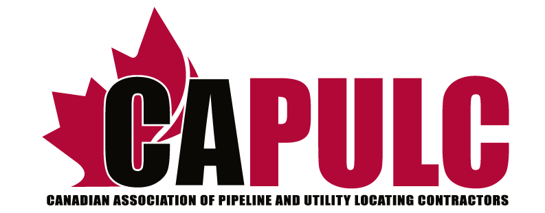
Sponsorship
Form

Please remit to:
The Canadian Association of Pipeline &
Utility Locating Contractors or CAPULC
PO Box 925, Station T
Calgary, Alberta T2H 2H4
Phone: 1-888-492-8279
Date: ____________________________________________
- Membership Selection
Sponsorship Type
Annual CAPULC Corporate sponsorships are promoted at the following levels: Check the box

Bronze* $ 500.00  Silver* $ 1000.00  Gold* $ 2500.00  Conference Lunch $ 2500.00  Guest Speaker $ 2500.00  Networking Event $ 1500.00  Early Bird Prize $ 1000.00  Conference Breakfast $ 1000.00 | Locate Rodeo BBQ $ 1000.00  Live Music $ 700.00  Rodeo Awards $ 500.00  Audio/visual $ 500.00  Shuttle Bus $ 500.00  Lanyards/name tags $ 500.00  Conference Program $ 250.00

2. Company Information
Company Name: ___________________________________________________________________
Mailing Address: ___________________________________________________________________
_________________________________________________________________________________
Phone #: ______________________________ | Website#: ___________________
3. Contact Information
Name: ___________________________________________________________________________
Title: ____________________________________________________________________________
Phone #: _________________________________________________________________________
E-mail: ___________________________________________________________________________
4. Payment Information
Cheque *Cheque are payable to CAPULC Credit Card *Invoices will be issued and payments can be made online

For more information about CAPULC Membership or Sponsorship contact:
Jason Mugford, Executive Director www.capulc.ca
*Plus GST

